CADET RANKS & PROMOTIONS

***BELOW ARE THE PROMOTION REQUIREMENTS. PROMOTION TESTING FOR THE RANKS OF PFC THROUGH SERGEANT WILL BE CONDUCTED BY THE PLATOON COMMANDERS OR A MEMBER OF THE SENIOR CADET STAFF.***

***CHAIN OF COMMAND MUST BE RECITED EXACTLY!***

***IF YOU FAIL TO WEAR YOUR UNIFORM ON A PRESCRIBED UNIFORM DAY, YOUR TIME FOR PROMOTION WILL BE RECALCULATED BY THE CADET COMMANDER!***

***IF YOU FAIL TO MAINTAIN A 2.0 IN ALL SCHOOL ACADEMICS, YOU WILL NOT BE PROMOTED!***

***YOU MUST EARN YOUR PROMOTION!***

***STAFF NCO AND OFFICER RANK PROMOTIONS WILL BE CONDUCTED BY A REVIEW BOARD CONSISTING OF THE CADET CO/XO, THE CADET'S PLATOON COMMANDER AND THE INSTRUCTORS.***

***\*\*PLATOON COMMANDERS - GET THE WRITTEN TESTS FROM THE INSTRUCTORS, AND RETURN THEM FOR GRADING AND PLACEMENT IN THEIR CADET RECORD BOOKS.***

**HOW DO I GET PROMOTED TO CADET PRIVATE FIRST CLASS?**

**- HAVE 9 WEEKS IN JROTC**

**- HAVE A "C" AVERAGE 2.0 OR HIGHER**

**- 100% UNIFORM WEAR WITH MODERATE DISCREPANCIES**

**- DOCUMENTED PARTICIPATION IN AT LEAST 1 UNIT EVENT FOR THE 9 WEEKS**

**- ALL ADMIN REQUIRED PAPERWORK TURNED IN**

**- RECITE FROM MEMORY YOUR CHAIN OF COMMAND FROM THE PRESIDENT DOWN TO THE REGION DIRECTOR**

**- PERFORM STATIONARY DRILL (IN-PLACE)**

**Position of Attention, right/left face, about face, parade rest, hand salute and backward march**

**- FOLD A FLAG**

**- TAKE A 10 QUESTION WRITTEN TEST ON GENERAL MILITARY KNOWLEDGE**

**- PLATOON COMMANDER WILL TURN IN YOUR RESULTS TO THE ADMIN OFFICER**

**- ADMIN OFFICER WILL GENERATE YOUR PROMOTION WARRANT AND SUBMIT TO THE SENIOR INSTRUCTOR FOR SIGNATURE, AND YOU WILL BE PROMOTED ON THE NEXT UNIFORM DAY IN FORMATION.**

**- ADMIN OFFICER WILL ENTER THE PROMOTION IN YOUR CADET RECORD BOOK**

**- DRAW YOUR NEW RANK INSIGNIA FROM SUPPLY AND TURN IN THE OLD ONES**

**- CONGRATULATIONS C/PFC!**

**HOW DO I GET PROMOTED TO CADET LANCE CORPORAL?**

**- HAVE 9 WEEKS IN JROTC AS A PRIVATE FIRST CLASS (PFC)**

**- HAVE A "C" AVERAGE 2.0 OR HIGHER**

**- 100% UNIFORM WEAR WITH MODERATE DISCREPANCIES**

**- DOCUMENTED PARTICIPATION IN AT LEAST 1 UNIT EVENT FOR THE 9 WEEKS**

**- ALL ADMIN REQUIRED PAPERWORK TURNED IN**

**- RECITE FROM MEMORY YOUR CHAIN OF COMMAND FROM THE PRESIDENT DOWN TO THE REGION DIRECTOR.**

**- YOUR PLATOON COMMANDER WILL MARCH YOU IN BASIC MARCHING DRILL**

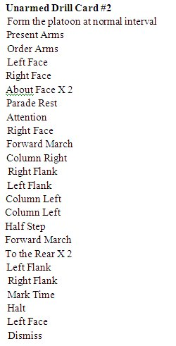

**- TAKE A 20 QUESTION WRITTEN TEST ON GENERAL MILITARY KNOWLEDGE**

**- ADMIN OFFICER WILL GENERATE YOUR PROMOTION WARRANT AND SUBMIT TO THE SENIOR INSTRUCTOR FOR SIGNATURE, AND YOU WILL BE PROMOTED ON THE NEXT UNIFORM DAY IN FORMATION.**

**- ADMIN OFFICER WILL ENTER THE PROMOTION IN YOUR CADET RECORD BOOK**

**- DRAW YOUR NEW RANK INSIGNIA FROM SUPPLY AND TURN IN THE OLD ONES**

**- CONGRATULATIONS C/LANCE CORPORAL (LCPL)!**

**HOW DO I GET PROMOTED TO CADET CORPORAL?**

**- HAVE 9 WEEKS IN JROTC AS A C/LANCE CORPORAL**

**- HAVE A "B" AVERAGE IN JROTC, AND A 2.0 OR HIGHER IN SCHOOL**

**- 100% UNIFORM WEAR WITH MINOR DISCREPANCIES**

**- DOCUMENTED PARTICIPATION IN AT LEAST 1 UNIT EVENT FOR THE 9 WEEKS**

**- RECITE FROM MEMORY YOUR CHAIN OF COMMAND FROM THE PRESIDENT DOWN TO THE REGION DIRECTOR.**

**- PROPERLY HOIST THE NATIONAL ENSIGN**

**- DIRECT A SQUAD (13 CADETS) IN UNARMED MARCHING DRILL AND IN-PLACE DRILL**



**- TAKE A 30 QUESTION WRITTEN TEST ON GENERAL MILITARY KNOWLEDGE**

**- ADMIN OFFICER WILL GENERATE YOUR PROMOTION WARRANT AND SUBMIT TO THE SENIOR INSTRUCTOR FOR SIGNATURE, AND YOU WILL BE PROMOTED ON THE NEXT UNIFORM DAY IN FORMATION.**

**- ADMIN OFFICER WILL ENTER THE PROMOTION IN YOUR CADET RECORD BOOK**

**- DRAW YOUR NEW RANK INSIGNIA FROM SUPPLY AND TURN IN THE OLD ONES**

**- YOU NOW RATE THE SERVICE ALPHA UNIFORM AND MAY DRAW IT FROM SUPPLY**

**- CONGRATULATIONS C/CORPORAL (CPL)!**

**HOW DO I GET PROMOTED TO CADET SERGEANT?**

**- HAVE 9 WEEKS IN JROTC AS A C/CORPORAL**

**- HAVE AN "A" AVERAGE IN JROTC, AND A 2.0 OR HIGHER IN SCHOOL**

**- 100% UNIFORM WEAR WITH VERY MINOR DISCREPANCIES**

**- DOCUMENTED PARTICIPATION IN AT LEAST 1 UNIT EVENT FOR THE 9 WEEKS**

**- RECITE FROM MEMORY YOUR 14 LEADERSHIP TRAITS AND YOUR CHAIN OF COMMAND FROM THE PRESIDENT DOWN TO THE REGION DIRECTOR**

**- DIRECT A SQUAD (13 CADETS) IN ARMED MARCHING DRILL AND IN-PLACE DRILL**

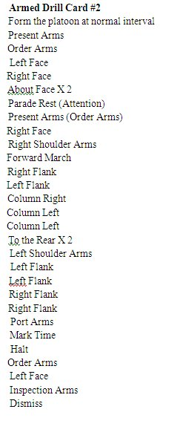

**- TAKE A 50 QUESTION WRITTEN TEST ON GENERAL MILITARY KNOWLEDGE**

**- DEMONSTRATE BASIC SWORD MANUAL**

**- DEMONSTRATE YOUR KNOWLEDGE OF BASIC COLOR GUARD MOVEMENTS**

**- ADMIN OFFICER WILL GENERATE YOUR PROMOTION WARRANT AND SUBMIT TO THE SENIOR INSTRUCTOR FOR SIGNATURE, AND YOU WILL BE PROMOTED ON THE NEXT UNIFORM DAY IN FORMATION.**

**- ADMIN OFFICER WILL ENTER THE PROMOTION IN YOUR CADET RECORD BOOK**

**- DRAW YOUR NEW RANK INSIGNIA FROM SUPPLY AND TURN IN THE OLD ONES**

**- CONGRATULATIONS C/SERGEANT (SGT)!**